se

1. Overview

This project is about building an intranet web service. This program is for the Daikibo employees exclusively. Therefore, only the credentials saved in Daikibo's database can be used for the login.

The service's main purpose is to visualise the statistics of Daikibo's products and facilities.

There are separated pages for every type of visualisation.

Visualisation has two sorting types: by factories and by machines.

This will help the users to utilise the historical data for analysis and consultation purposes.

All the data will be uploaded and updated for visualisation on regular bases, and this will be managed by the DBA.

2. Scope

The project's main feature is the visualisation of the json dataset of the Daikibo company.

After the credential authentication, the user can access the data from the home page.

Accessing the raw dataset is optional, depending on a DBA's decision.

Visualisation has two sorting types: by factories and by machines.

1. By factories

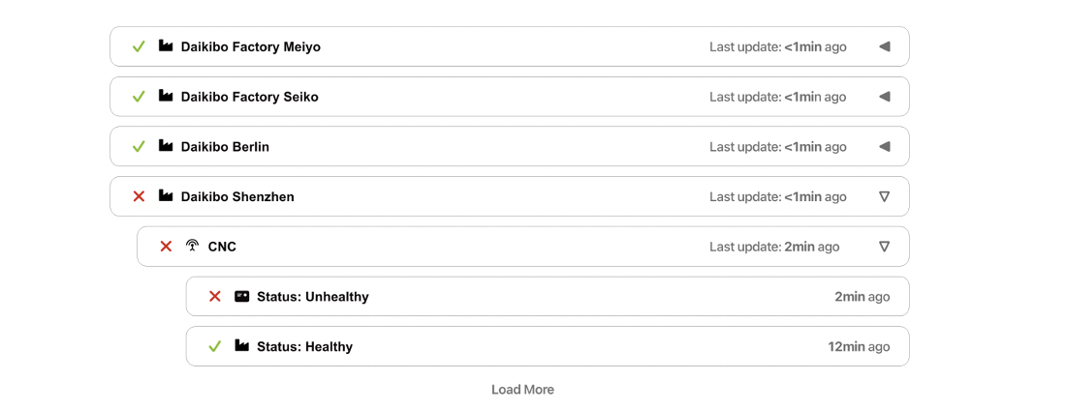

There are four factories in Daikibo: Meiyo, Seiko, Berlin, and Shenzhen.

All data is collected and visualised on factory bases. Therefore, users can easily compare and analyse the main product of the factory and the changes.

2.By products

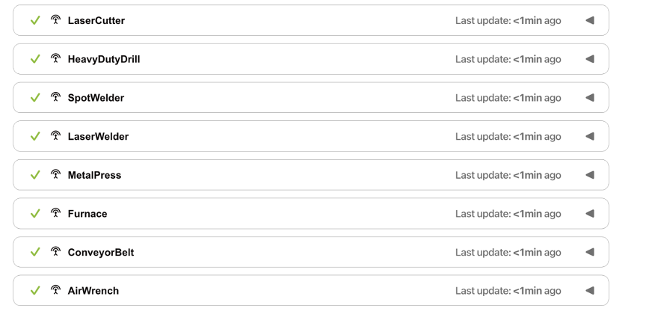

There are nine products in Daikibo: LaserCutter, HeavyDutyDrill, SpotWelder, LaserWelder, MetalPress, Furnace, CoveyorBelt, and AirWrench.

All data is collected and visualised on product bases. Therefore, users can easily compare and analyse the annual, and seasonal production of the product and the changes.

3. Estimate

|  |  |  |
| --- | --- | --- |
| Stage | | Time |
| Development | Making SRS (Software Requirement Specification) | 5 Hours |
| Understanding data structure and build database | 5 Hours |
| Establish automated data preproduce algorithm | 7~10 Hours |
| Code for visualisation of the data | 10~15 Hours |
| UI/UX | 10~15 Hours |
| Testing | Internal | 5~10 Hours |
|  | Prototype | 5~10 Hours |
| Integration | | 5~10 Hours |
| Publish | | 5~10 Hours |
| Total | | 47~90 Hours |

4. Timeline

1. [8th of August 2022] Making SRS Starts
2. [10th of August 2022] Making SRS Finish
3. [11th of August 2022] Understanding data structure and build database Starts
4. [12th of August 2022] Understanding data structure and build database Finish
5. [12th of August 2022] Establish automated data preproduce algorithm Starts
6. [15th of August 2022] Establish automated data preproduce algorithm Finish
7. [15th of August 2022] Code for visualisation of the data Starts
8. [18th of August 2022] Code for visualisation of the data Finish
9. [18th of August 2022] UI/UX Starts
10. [20th of August 2022] UI/UX Finish
11. [20th of August 2022] Internal testing Starts and Finish
12. [22th of August 2022] Prototype testing Starts and Finish
13. [23th of August 2022] Integration Starts and Finish
14. [24th of August 2022] Publish the project

5. Support

This project is related with the internal database structure and the Daikibo's DBA.

Therefore, updates on the algorithm and the structure is needed on a regular bases.

And the continuous supports and the communications will be guaranteed for the after care service as a platform provider.